

SIMATS ENGINEERING

Saveetha Institute of Medical and Technical Sciences
Chennai- 602105

Student Name:B.Karunyeswari Reg. No.:192424235
Course Code:DSA0216 Slot: B
Course Name: Computer Vision with Open CV for Modern AI
Course Faculty: Dr. Senthilvadivu S & Dr. T. Kumaragurubaran
Project Title: Vision Based Sign Language Recognisation Using Cnn

Module Photographs: (3 photographs –Module Photo, Individual student contribution module work in the project and presentation image)
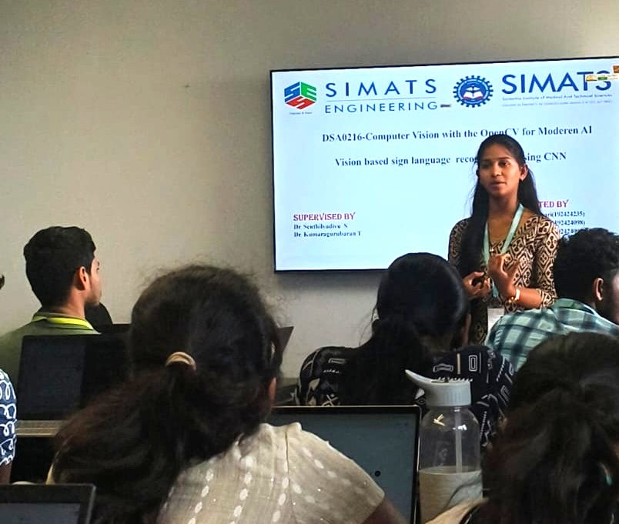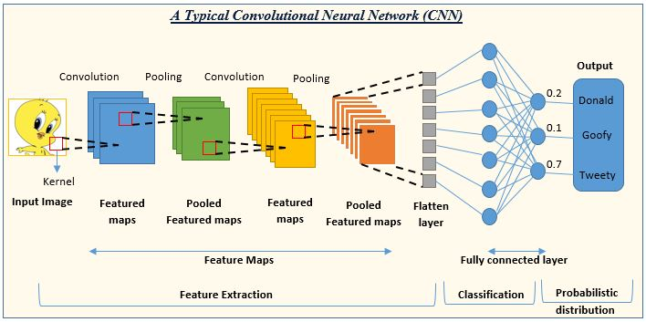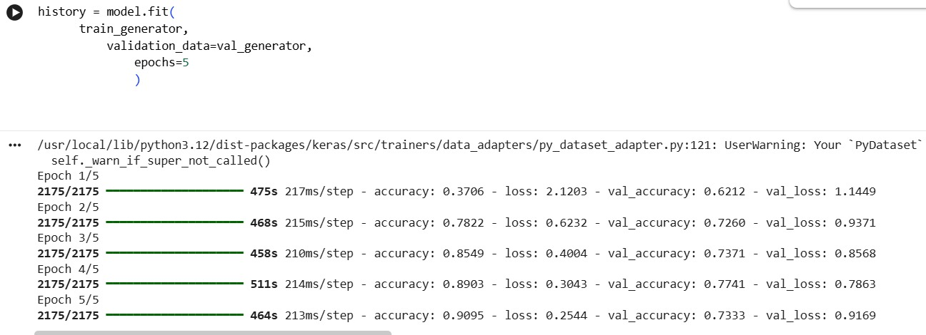

Project Description: (here you write what you did in this project (contribution) including Model Description
The Vision Based Sign Language Recognition System is designed to automatically recognize hand gestures representing sign language using a camera. It helps convert sign gestures into readable text, enabling better communication between hearing-impaired individuals and others. The system ensures accurate detection and reduces the need for manual interpretation.
The Data Acquisition Module handles capturing real-time images or video frames from a webcam. It records gesture images, preprocesses them by resizing and normalizing, and prepares the dataset for training and testing. This module ensures that the input data is clear, consistent, and suitable for further processing.
The CNN-Based Gesture Recognition Module performs the core task of recognizing sign language gestures. It uses a Convolutional Neural Network (CNN) to extract important features from gesture images such as edges, shapes, and patterns. The trained CNN model classifies the gesture into the corresponding alphabet or word. This module ensures high accuracy by learning from large datasets and improving performance through training.
The Prediction and Output Module converts the recognized gesture into text format and displays it on the screen. This helps users understand the intended message quickly and effectively.

Student Signature Guide Signature

